**Home Page:**

[http://wantro.com/creative2/home/index.php#](http://wantro.com/creative2/home/index.php)

Menu not working

Remove them: (ENGLISH at top and facebook icon at bottom of page)

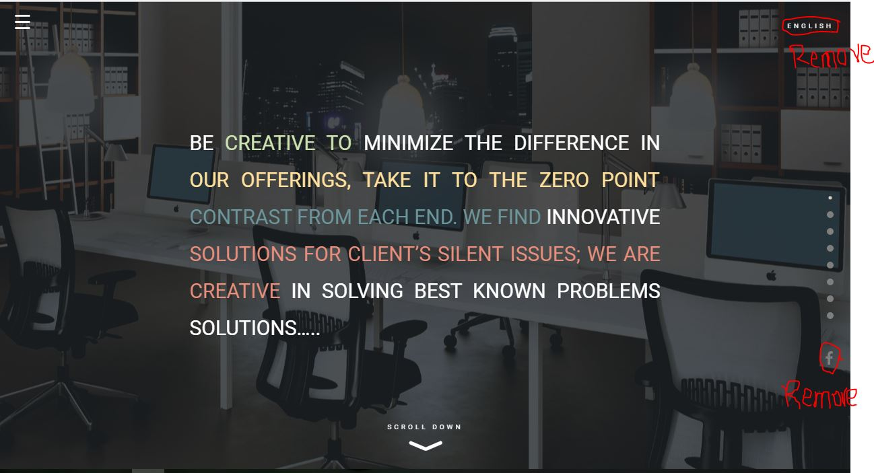

Update following sections:

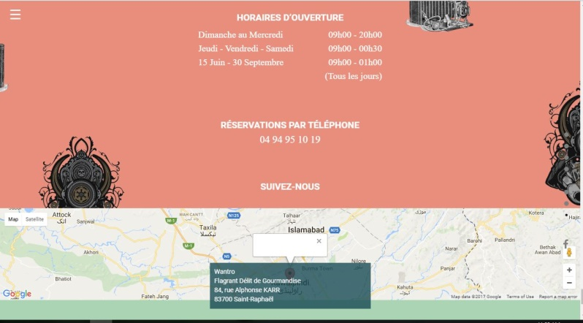

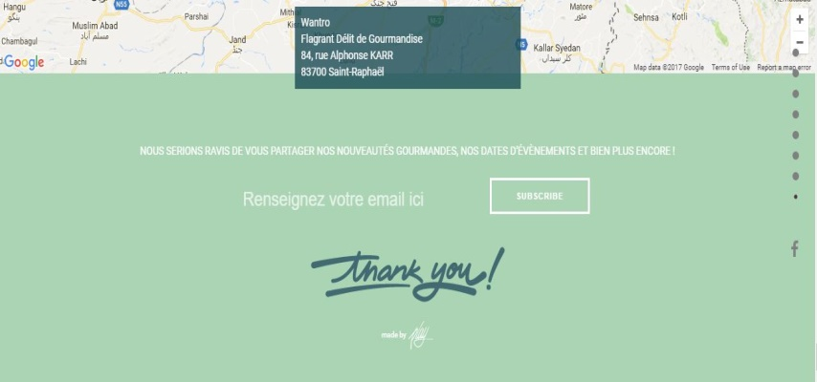

**About us page:**

<http://wantro.com/creative2/about-us/about-us.php>

Animation on this page not work properly: text part hide more than half first image:

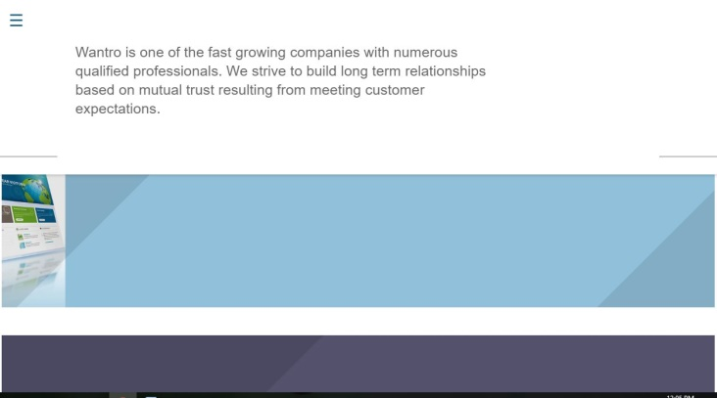

Image and text not aligned properly:

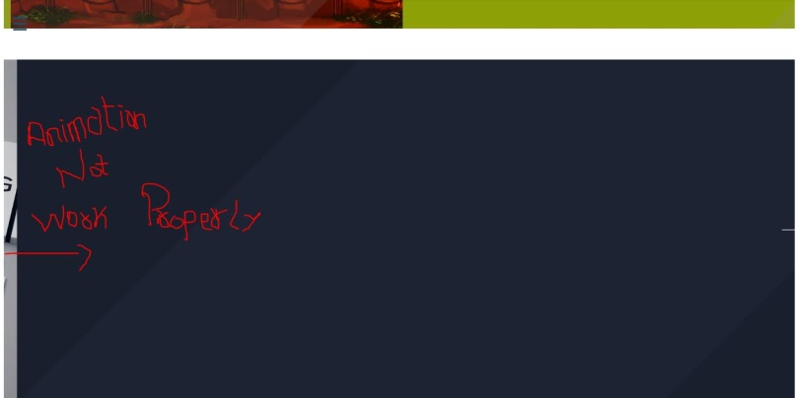

**Services Page:**

<http://wantro.com/creative2/services/index>

Menu missing

Resolve this Error

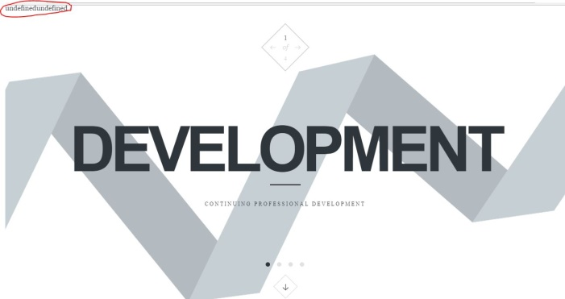

<http://wantro.com/creative2/services/promotion-campaigning.php>

Text missing: first paragraph is missing:

“The world of marketing is changing at a rapid pace. There are so many new developments taking place with the promotional and campaigning arena every day. At Wantro, our expert team of promotion and campaigning remains ahead of the curve. Our Promotion team is well versed with the latest online marketing trends.”

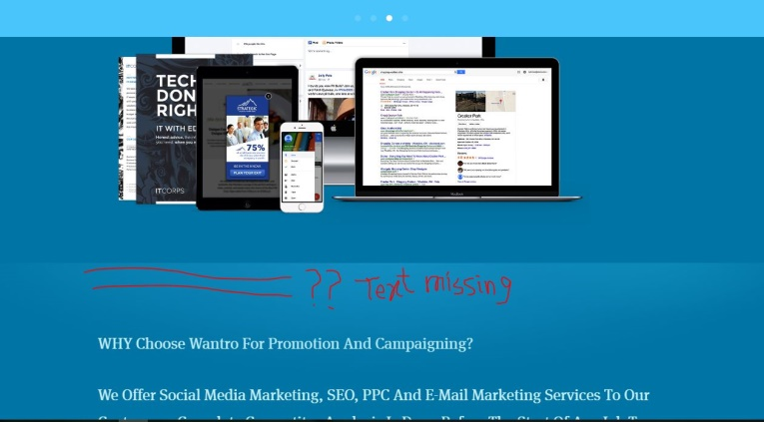

**Design Page:**

<http://wantro.com/creative2/design/featured.php>

Change image pop-up size to full screen: (All Images)

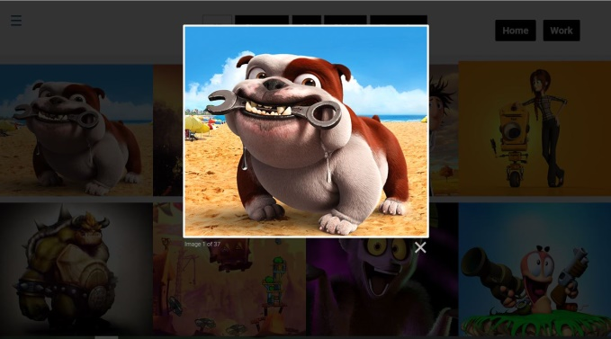

**Mobile Development:**

<http://wantro.com/creative2/Mobile-development/index.php>

Menu not working

**Software development:**

<http://wantro.com/creative2/software-development/>

Heading of C# &VB.Net is missing

VB.net and C++ both have C# image

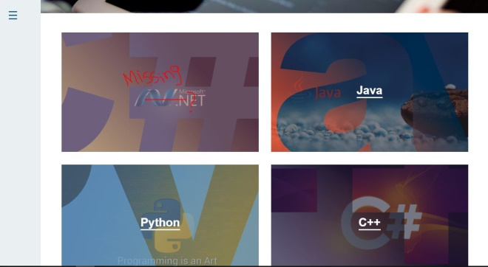

Remove link from Wantro:

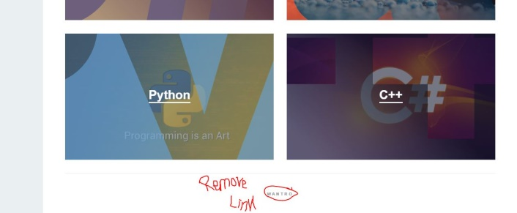

<http://wantro.com/creative2/software-development/java>

First paragraph of text is missing:

“Extensive experience in java development, rich client presentation technologies and frameworks such as Play, JSF, Spring MVC, Struts 2, AJAX, GWT, Prototype, Velocity, WebWork, Tiles, Groovy/Grails, and Swing, as well as Eclipse-based RCP and RAP frameworks. We build truly engaging user experiences through single-page applications using HTML5 and modern JavaScript web frameworks such as AngularJS, Knockout, Backbone.js, and Boilerplate JS.”

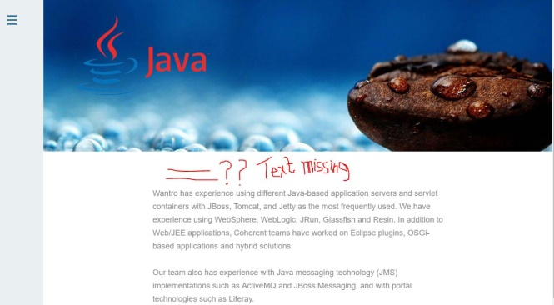

**Game Development:**

<http://wantro.com/creative2/game-development/>

Remove links from text

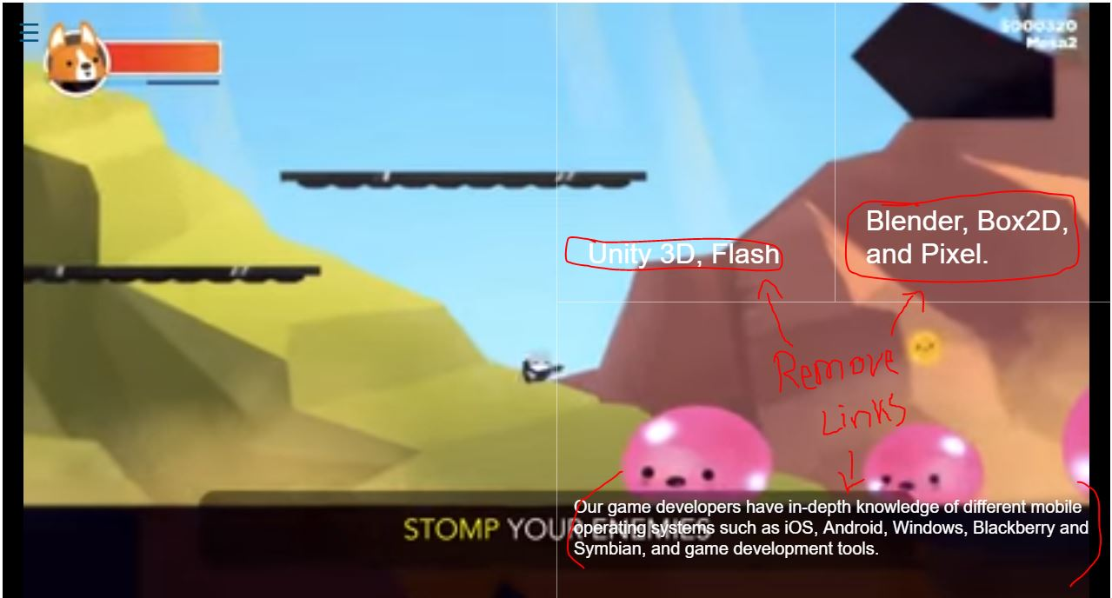

**Consultancy Page:**

<http://wantro.com/creative2/Consultancy/consultancy.php>

Menu missing on this page

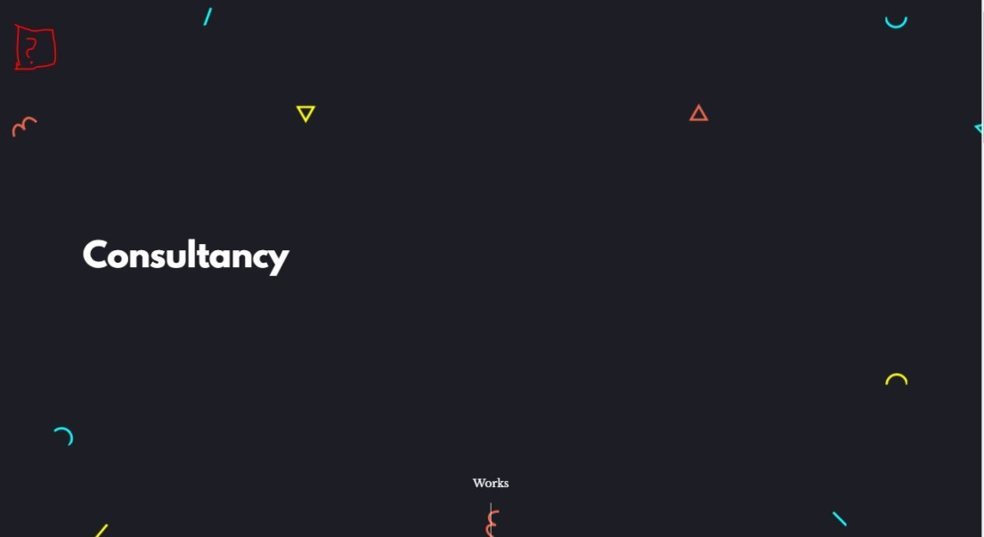

**Promotion Page:**

<http://wantro.com/creative2/Promotion/Space-Ape-Games.php>

Rocket is missing:



Insert links of next pages in the headings also:

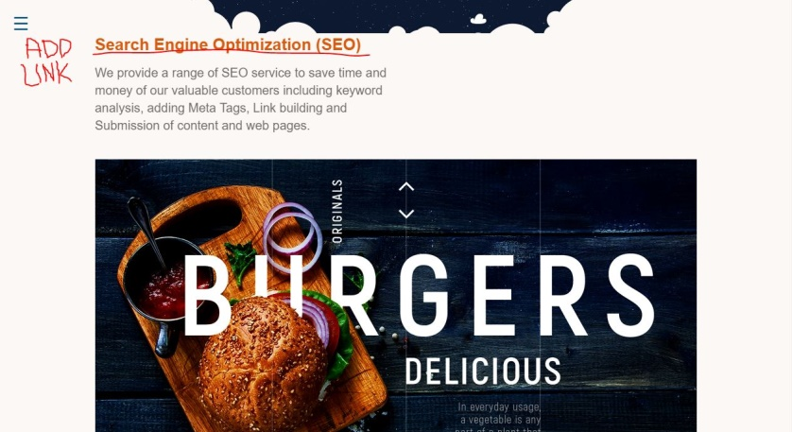

Page scroll at the top when close any next page or click on the heading

<http://wantro.com/creative2/Promotion/space-project.php>

Set the image size on header of all promotion projects:

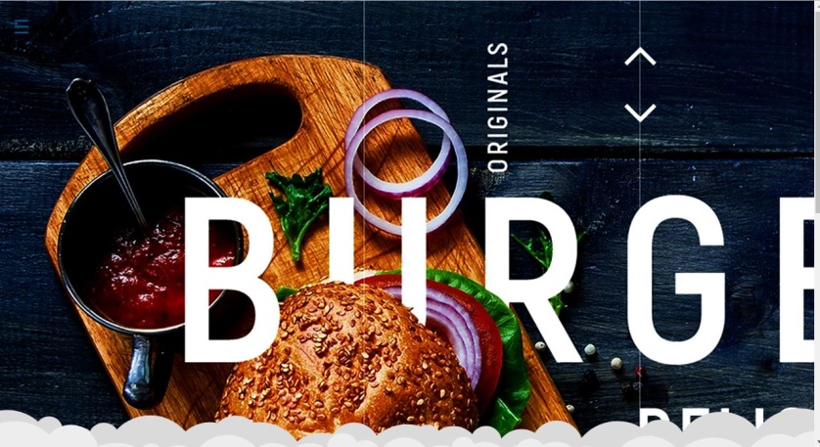

Add blog page link in blog button:

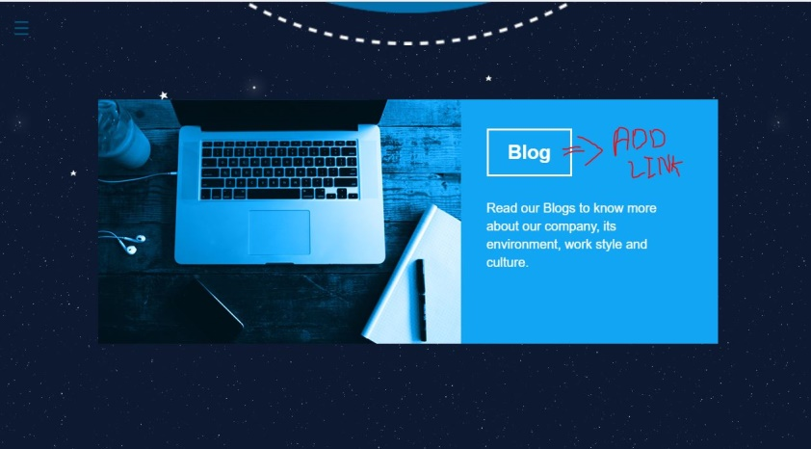

**Team Page:**

<http://wantro.com/creative2/Team/>

Set images and text:

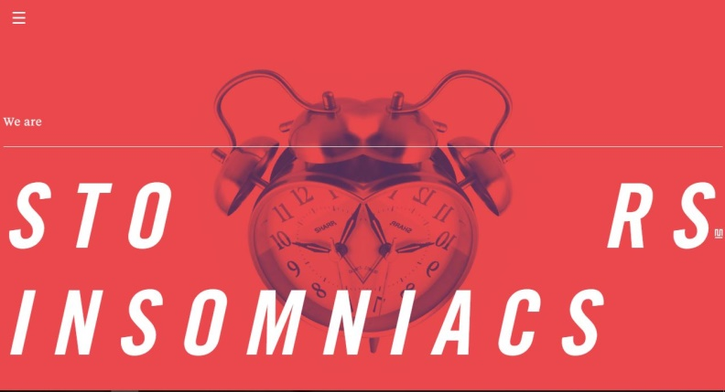

<http://wantro.com/creative2/Team/about-ceo>

Remove Colon sign:

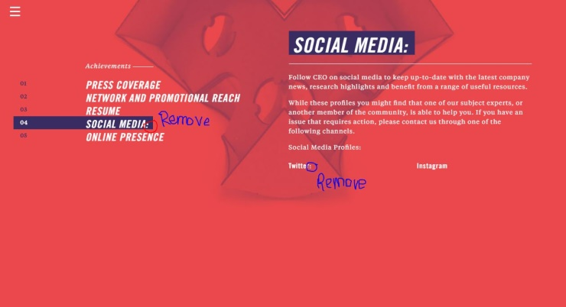

<http://wantro.com/creative2/Team/work>

Page scroll at the top at every click

Replace the image of David with David in “Higher Management”



Replace the NATASHA SPARE at fourth number with “Robin” “Art Director” from Designing



Add background color on all employees name to make it readable:



Change name to Chris:



Change content of Stefan in Game Development:

“Stefan takes care of programming and game design. Armed with logic and maths there’s nothing Stefan can’t build!

He earned his stripes during University studying computer science. He survived by exchanging PC repairs for vodka with the 5 art students he lived with. Despite losing his love for vodka, all things computer still engage him.

Stefan took his first step into video game production with a program combining a virtual pet hamster with Tetris. Awesome.”

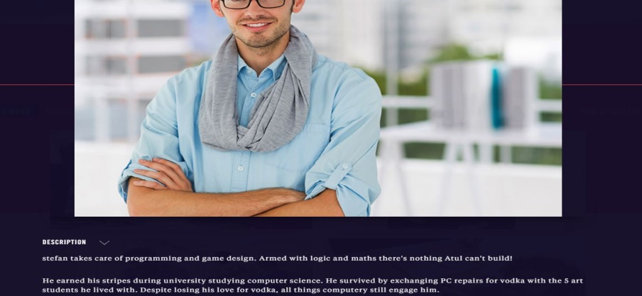

<http://wantro.com/creative2/Team/work?filter=social>

Change spellings of higher from Heigher

Cannot open the pop-up for information in Higher Management.

Change the hover effect on David Image in Higher Management. (only image shadow)

<http://wantro.com/creative2/Team/hr-manager>

In HR image of Monica cannot change in pop-up window

 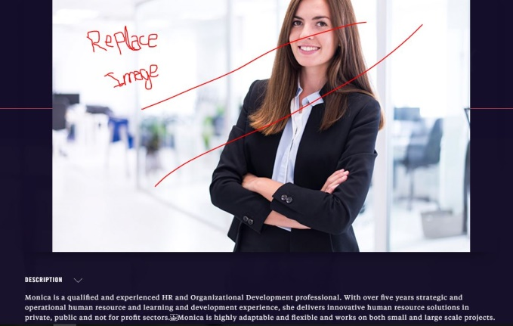

Change text of SAM in Web Development:

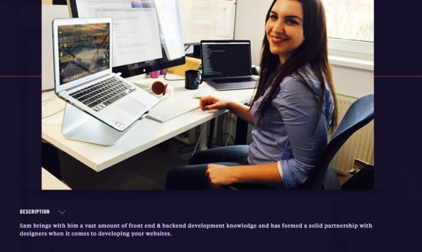

Sam is an expert at developing the technical mumbo-jumbo that goes on behind the pictures you see on your computer screen. With an initial background in digital marketing, Sam has combined this with her web development expertise to ensure a smooth and engaging user experience for your clients when they browse your website.

Change text of NITIN in web development

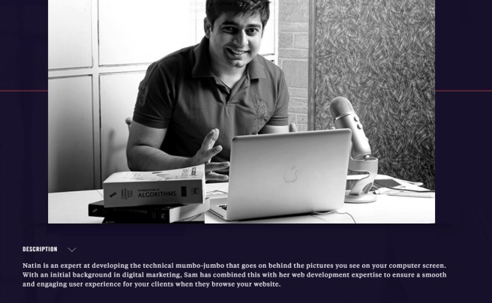

Nitin brings with him a vast amount of front end & backend development knowledge and has formed a solid partnership with designers when it comes to developing your websites.

<http://wantro.com/creative2/Team/teamlead>

Change name from Team Leads to Team Leads and management

Menu is not working on this page: Update content of this page:

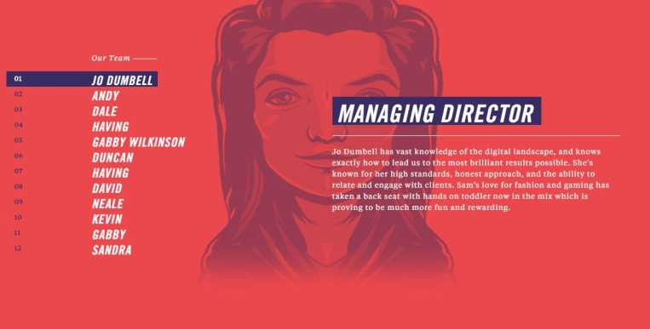

**Marketing Reach:**

<http://wantro.com/creative2/Marketing/grid>

Menu is missing

Replace logo or icon with “WANTRO”

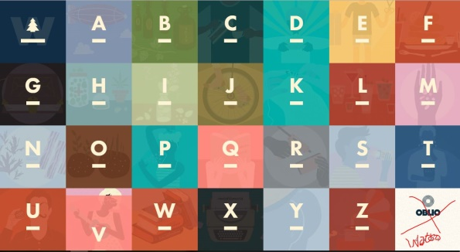

<http://wantro.com/creative2/Marketing/>

Change content of this page:



Market Target Business

Marketing Reach

Content on button is not readable:

Remove the about or link it with About us page

**Testing:**

<http://wantro.com/creative2/Testing/index.php>

Change font color, it’s not readable

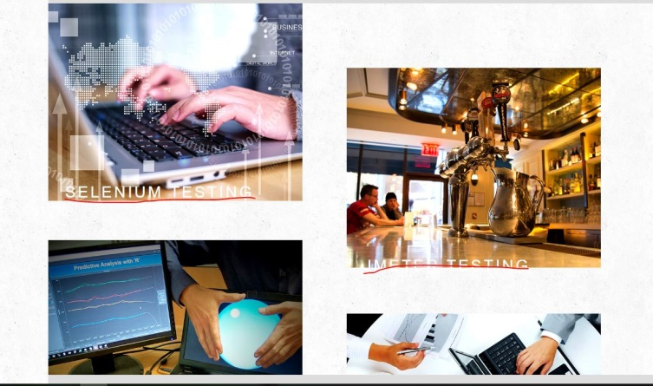

Next and previous button just change the background color but not text and image:

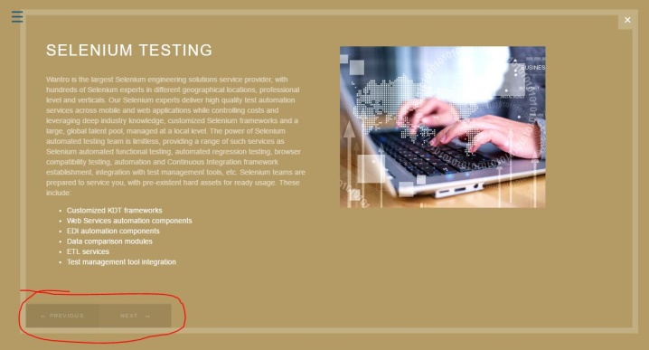

**Blog:**

<http://wantro.com/creative2/Blog/index.php>

text formation: “and” will be on next line.

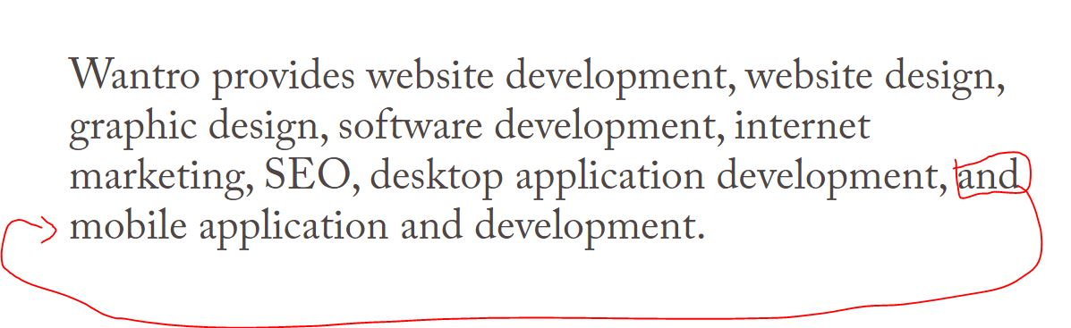

<http://wantro.com/creative2/Blog/technology.php>

Blog heading missing:

Decrease the font size of following text:



New paragraph will be started from marked point:

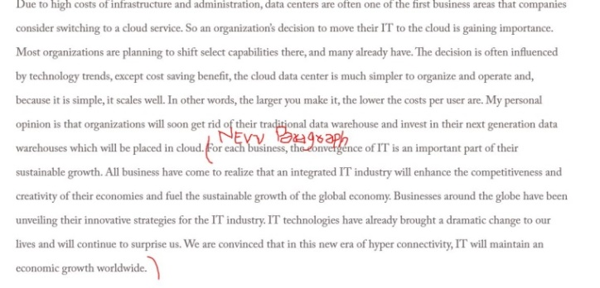

**Kickstarter:**

Page not open from menu: (404 error)

Menu not working properly:

<http://wantro.com/creative2/home/index.php>

Change image:

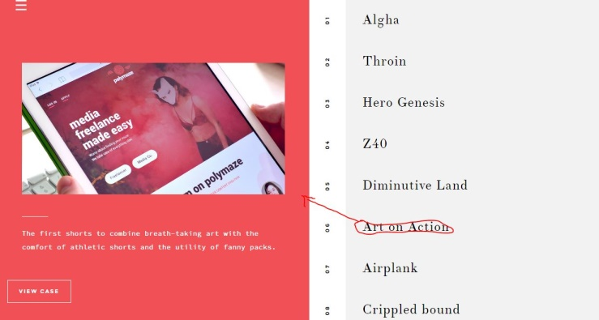

**PAGES MISSING:**

Development

Web Development

Events

**Pages Not Done:**

Portfolio